**Execute Testng.xml from command line**

Reference - http://www.seleniumeasy.com/testng-tutorials/how-to-run-testng-xml-webdriver-tests-from-command-line

[Home](http://www.seleniumeasy.com/) >> [TestNG Tutorials](http://www.seleniumeasy.com/testng-tutorials) >> [Execute Testng.xml from command line](http://www.seleniumeasy.com/testng-tutorials/how-to-run-testng-xml-webdriver-tests-from-command-line)

We can execute testng.xml file in different ways.

1. Eclipse  
2. InteliJ  
3. Ant / Maven  
4. Command Line  
5. Batch File.

In IDE you can just right click on testng.xml file and click on Run as 'TestNG' will invoke your tests. And we can also [invoke TestNG.xml with Ant build.xml file](http://www.seleniumeasy.com/ant-tutorials/how-to-run-testng-tests-using-build-xml-file) and we also by doing some simple [configuration to maven pom.xml](http://www.seleniumeasy.com/maven-tutorials/how-to-execute-selenium-webdriver-testng-xml-using-maven) which we have see examples earlier

Now let us see how to invoke testng.xml from command line step by step:

**Step 1:** Create new project, In example we have created project 'SampleTestNG'

**Step 2:** Create new package. 'com.test' as example package created here.

**Step 3:** Create sample classes which has @Test methods. In the example below we have created four classes as below :

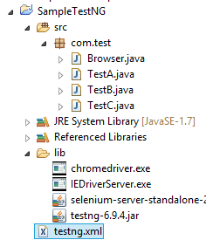

Class - Browser.java, which has getBrowser(String browserType) method which accepts browser Type and returns driver based on the string passed by the user.

**package** com.test;

**import** org.openqa.selenium.WebDriver;

**import** org.openqa.selenium.chrome.ChromeDriver;

**import** org.openqa.selenium.firefox.FirefoxDriver;

**import** org.openqa.selenium.ie.InternetExplorerDriver;

**public** **class** **Browser** {

**static** String driverPath = "F:/Selenium/SampleTestNG/lib/";

**public** **static** WebDriver driver;

**public** **static** WebDriver **getBrowser**(String browserType) {

**switch** (browserType) {

**case** "firefox":

**return** driver = **new** FirefoxDriver();

**case** "chrome":

System.setProperty("webdriver.chrome.driver", driverPath+"chromedriver.exe");

**return** driver = **new** ChromeDriver();

**case** "IE":

System.setProperty("webdriver.ie.driver", driverPath+"IEDriverServer.exe");

**return** driver = **new** InternetExplorerDriver();

**default**:

System.out.println("browser : " + browserType + " is invalid, Launching Firefox as browser of choice..");

**return** driver = **new** FirefoxDriver();

}

}

}

We will now try to create three different classes each passing different browser type (Firefox, chrome and InternetExplorer) and create test method in each class.

First create a class and get browser firefox :

**package** com.test;

**import** org.openqa.selenium.WebDriver;

**import** org.testng.Assert;

**import** org.testng.annotations.AfterClass;

**import** org.testng.annotations.BeforeClass;

**import** org.testng.annotations.Test;

**public** **class** **TestA** {

WebDriver driver;

@BeforeClass

**public** **void** **setUp**() {

System.out.println("*******************");

System.out.println("launching firefox browser");

driver = Browser.getBrowser("firefox");

driver.manage().window().maximize();

}

@Test

**public** **void** **testGooglePageTitleInFirefox**() {

driver.navigate().to("[http://www.google.com"](http://www.google.com/));

String strPageTitle = driver.getTitle();

Assert.assertTrue(strPageTitle.equalsIgnoreCase("Google"), "Page title doesn't match");

}

@AfterClass

**public** **void** **tearDown**() {

**if**(driver!=**null**) {

System.out.println("Closing firefox browser");

driver.quit();

}

}

}

Create another class 'TestB.java' and get browser chrome driver to [execute tests in chrome browser](http://www.seleniumeasy.com/selenium-tutorials/how-to-run-webdriver-in-chrome-browser) :

**package** com.test;

**import** org.openqa.selenium.WebDriver;

**import** org.testng.Assert;

**import** org.testng.annotations.AfterClass;

**import** org.testng.annotations.BeforeClass;

**import** org.testng.annotations.Test;

**public** **class** **TestB** {

WebDriver driver;

@BeforeClass

**public** **void** **setUp**() {

System.out.println("*******************");

System.out.println("launching chrome browser");

driver = Browser.getBrowser("chrome");

driver.manage().window().maximize();

}

@Test

**public** **void** **testGooglePageTitleInChrome**() {

driver.navigate().to("[http://www.google.com"](http://www.google.com/));

String strPageTitle = driver.getTitle();

Assert.assertTrue(strPageTitle.equalsIgnoreCase("Google"), "Page title doesn't match");

}

@AfterClass

**public** **void** **tearDown**() {

**if**(driver!=**null**) {

System.out.println("Closing chrome browser");

driver.quit();

}

}

}

Create another class 'TestC.java' and get browser chrome driver to [execute tests in IE browser](http://www.seleniumeasy.com/selenium-tutorials/how-to-run-webdriver-in-ie-browser):

**package** com.test;

**import** org.openqa.selenium.WebDriver;

**import** org.testng.Assert;

**import** org.testng.annotations.AfterClass;

**import** org.testng.annotations.BeforeClass;

**import** org.testng.annotations.Test;

**public** **class** **TestC** {

WebDriver driver;

@BeforeClass

**public** **void** **setUp**() {

System.out.println("*******************");

System.out.println("launching IE browser");

driver = Browser.getBrowser("IE");

driver.manage().window().maximize();

}

@Test

**public** **void** **testGooglePageTitleInIEBrowser**() {

driver.navigate().to("[http://www.google.com"](http://www.google.com/));

String strPageTitle = driver.getTitle();

System.out.println("Page title: - "+strPageTitle);

Assert.assertTrue(strPageTitle.equalsIgnoreCase("Google"), "Page title doesn't match");

}

@AfterClass

**public** **void** **tearDown**() {

**if**(driver!=**null**) {

System.out.println("Closing IE browser");

driver.quit();

}

}

}

The below is the testng.xml file, which will execute all the tests that are available under 'com.test' package.

In the above classes, each class has a test method with @Before and @After class which will open browser, validate Google Home page title and close browser. In IDE, it is very simple to execute to click on Run as TestNG.

The below is the testng.xml file

<?xml version="1.0" encoding="UTF-8"?>

<!DOCTYPE suite SYSTEM "[http://testng.org/testng-1.0.dtd"](http://testng.org/testng-1.0.dtd) >

<**suite** name="Main Test Suite" verbose="2">

    <**test** name="TestNG Test Group">

*<!-- <classes>*

*<class name="com.test.TestA"/>*

*</classes> -->*

        <**packages**>

        <**package** name="com.test"/>

        </**packages**>

    </**test**>

</**suite**>

Here is below commands to execute 'testng.xml' file from command line

**cd** F:\Selenium\SampleTestNG

java -cp F:\Selenium\SampleTestNG\lib\*;F:\Selenium\SampleTestNG\bin org.testng.TestNG testng.xml

After executing above command, it should execute the tests that we have specified in testng.xml file. And the below is the screen shot after executing the tests.

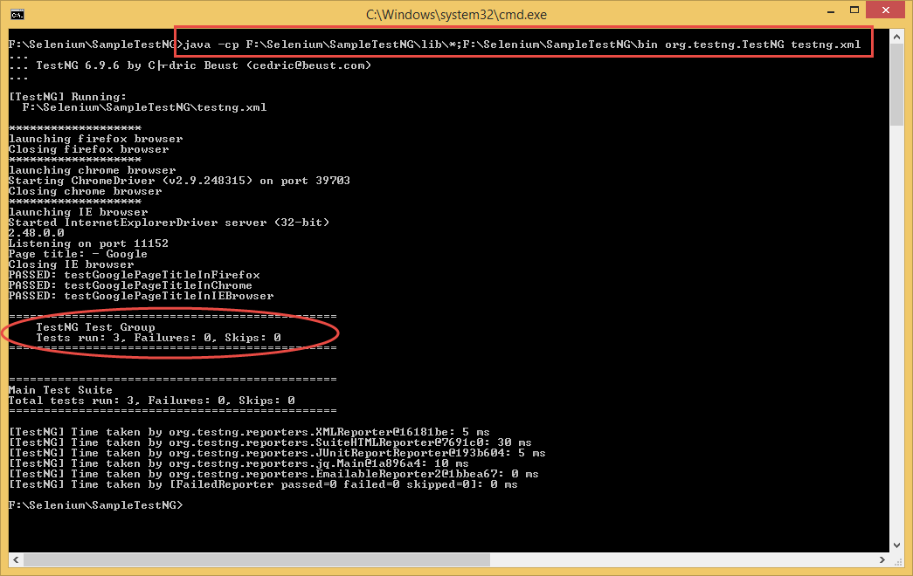

In the above command, for 'java -cp' argument, we provide the classpath i.e. path to classes / libraries that our program requires to run. You can check out [Oracle Docs](http://docs.oracle.com/javase/6/docs/technotes/tools/windows/classpath.html) for more information on class path.